Kickstart Analysis Report

* What are three conclusions we can make about Kickstarter campaigns given the provided data?

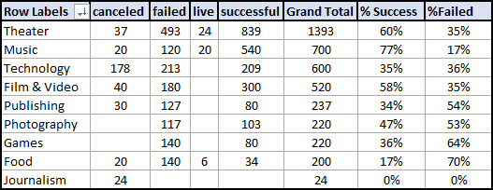

Theater has almost twice the amount of campaigns as Music; however, Music has a 77% successful rate, making Music a very attractive category for future campaigns.

Rock is the highest subcategory performer within the Music category with a 100% successful rate. Metal, Jazz, Electronic Music, and classic Music are also very successful but with a low amount of campaigns.

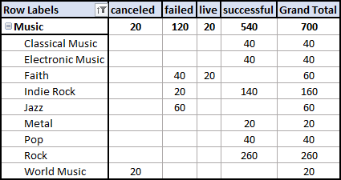

Plays is the highest subcategory performer within the Theater category with a 65% successful rate.

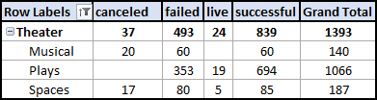

However, the best subcategory there is Hardware with an average daily pledge of $126,838 and a 100% percent success.

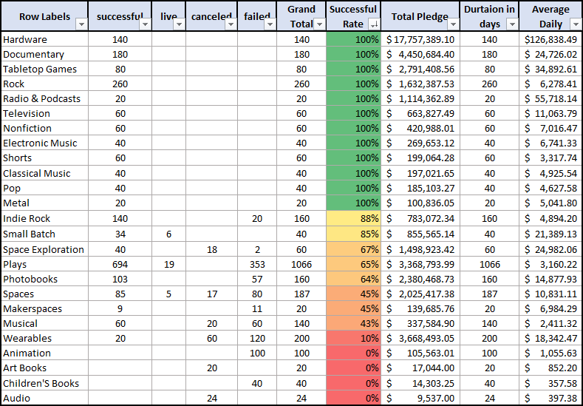

Despite there are nine countries working with Euros, the US is the best country/currency to run campaigns, and the British pound sterling is also a good performer. The US has an average pledge per backer of US$153,706.33.

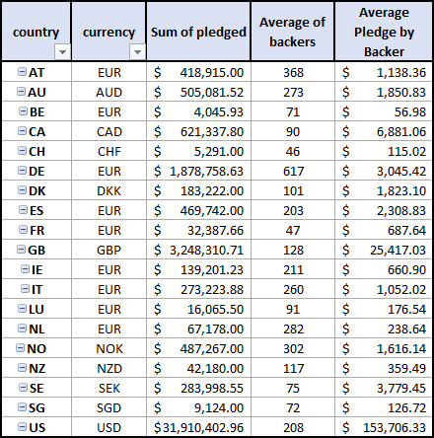

* What are some of the limitations of this dataset?

The data is a small population sample and might skew the data allowing false high performers selections. In contrast to the stated in the assignment abstract, the data shows about fifty percent success rate versus the overall (300.000 projects) one-third of the launched projects.

It is unclear whether the listed country is where projects will take place; a geographical data point for backers and project location could explain some of the outliners in the population sample.

Further information about the return of the investment for the backers would allow future companies siking funding to entice the givers with the business plan. Also, this information would enable risk-taken analysis.

* What are some other possible tables/graphs that we could create?
* Table of categories with total per status, calculating the percentage of successful and unsuccessful campaigns along with max, min average of the goals, and max and average for the pledge.

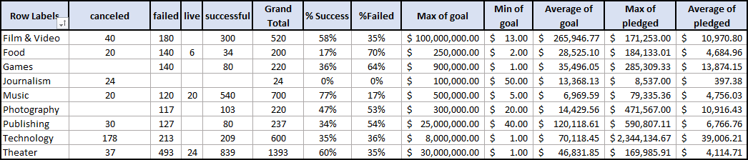

* A table of Subcategories status, total campaigns, calculated successful rate, total pledge rate, duration days, and the average pledge per day.
* Graph of average donation versus day duration could help the project team to estimate launch times and duration.

Bonus II

* Use your data to determine whether the mean or the median summarizes the data more meaningfully.

The mean seems to summarize the data better; however, the outliers skew the data significantly.

* Use your data to determine if there is more variability with successful or unsuccessful campaigns. Does this make sense? Why or why not?

Successful projects have more variability.

Yes, it makes sense; it is supported by the diversity of subcategories, average donations.